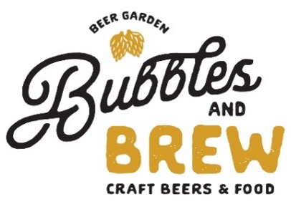

Wine Flights & More

By the Glass Flights
Reds Bubbly & Bright Sparkling Wines 23
Pinot Noir, Benton Lane, Willamette Valley, OR 13/14 Pol Clement Rose Sec, France
Pinot Noir, Morgan ‘Twelve Clones’, SLH, CA 15/30 Vila Sandi Prosecco, Italy
Pinot Noir, Carpe Diem, Anderson Valley, CA 16/60 Gruet, Blanc de Blancs, New Mexico
Cabernet, Coppola Director’s Cut, Sanoma, CA 14/15
Cabernet, Daou, Paso Robles, CA 2021 15/50 California Chardonnay 24
Cabernet, Justin, Paso Robles, CA 202 16/60 St. Huberts “The Stag”, Santa Barbara, CA 2020
Meritage, Bubbles Cellars, Central Coast, CA 10/35 Daou, Paso Robles, CA 2021
Rombauer, Carneros, CA 2021

Whites Elegant Pino Noir 25
Pinot Gris, King Estate, Willamette Valley, OR 12/40 Benton Lane, Willamette Valley, OR 2019
Chardonnay, St Huberts, “The Stag”, SB, CA 13/45 Morgan ’Twelve Clones”, S.L Highlands, CA 2019
Chardonnay, Daou, Paso Robles, 2021 15/50 Carpe Diem, Anderson Valley, CA 2019
Chardonnay, Rombauer, Carneros, CA 2021 19/75
Chardonnay, Bubbles Cellars, Monterey, CA 10/35 New World Cabernets 25
Sauvignon Blanc, Napa Cellar, Napa Valley, CA 13/45 Coppola ‘Director’s Cut’, Sanoma, CA 2020
Viognier, Zaca Mesa, Santa Ynez Valley, CA 12/40 Daou, Paso Robles, CA 2021
Moscato d’Asti, Saracco, Piedmont, Italy 10/35 Justin, Paso Robles, CA 2020
Mom-Alcoholic Chardonnay, Hand on Heart 12/40

Rose’ Bubbly Cocktails
Les Sarrins, Provence, France 2021 10/35 Strawberry-Rose’ Froze’ 13
Daou, Paso Robles, CA 2021 12/45 Coconut Rum Crush 13
King Estate, Willamette Valley, OR 2020 12/40 Bubbs Orange Mimosa 11
Bloody Mary 13
Sparkling Sangria 12
Sparkling Bubbles Red Sangria/Carafe 12/40
Pol Clement Rose Sec, France 10/35 Strawberry Sparkler 11
Gruet, Blanc de Blancs, New Mexico 12/40 Bubbles Peach Bellini 11
Segura Viudas, Cava, Spain 10/35 Wine Island 13
Villa Sandi Prosecco, Italy 10/35
Schramsberg Blanc de Blanc, North Coast 18/65
Guglielmo, Almond, Ca 10/35 Beverages
(no refills)
Coffee/Hot Tea: Chai or Green 5
Dessert & Port Wines Fentimans Ginger Beer 5
Graham’s 10-Year Tawny Port, Portugal 15/75 Erdinger Non-Alcoholic Beer 8
Blandy’s 10-Year Madiera, Portugal 12/45 Coke/Sprite/Diet Coke 4
Hanks Black Cherry or Vanilla Cream Soda 5
Martinelli Sparkling Cider 4
Lemonade/A. Palmer/Iced Tea/Sparkling Water 4

